**Smart Mall Map Software**

* **Project Description:**
* A software program that tends to be installed on a touch screen hardware at a Shopping Mall that views the map of the mall and assist the visitors with directions and information about any facility in the mall.
* **Development Tools:**
* Using Java Language
* Applying Object-Oriented Programming concepts
* Java Swing for GUI
* Developed with NetBeans IDE
* Apache Derby for Database
* **Project Development Team:**
* Yousef Hussien **(Team Leader)**
* Omar Mohamed
* Mostafa Hossam
* Omar Osama
* Mohamed El-Shahat
* **Project Deliveries:**
* **Phase 1:** Project Requirements
* **Phase 2:** Analysis and Design
* **Phase 3:** Implementation
* **Phase 4:** Testing
* **Phase 5:** Reviews and Documentation
* **Requirements Engineering:**
* **Functional Requirements:**

|  |  |
| --- | --- |
| Search for a facility | A visitor shall be able to search for facility inside the mall map. |
| Get direction to a facility | A visitor shall be able to get direction to the facility that they choose or searched from the mall map. |
| View facility information | A visitor shall be able to view info about the facility that they chose or searched for information like (opening and closing time, offers, phone number and for cinema they can check is it full or empty). |
| File a complain | A visitor shall be able to call customer service to get support or to report a problem. |
| Add facility | Admin should be able to add facility in the map. |
| Manage map | Admin should be able to update and delete a facility inside the map. |
| Set announcement | Admin should be able to set an announcement inside the mall map. |
| Add advertisement | Advertisers post the advertisements on the map and the admin should confirm it. |
| Manage facility information | Facility actor should be able to update and delete the facility information. |
| Add facility information | Facility actor should be able to add the new facility information. |

* **Non-Functional Requirements:**

|  |  |
| --- | --- |
| Robustness | The system should be recovering after one minute. |
| Reliability | The system should not go down more than two times in every 3 months (The downtime should not exceed 4 minutes). |
| Flexibility | The system should support 3 languages (Arabic-English-French). |
| Speed | The system should give direction to visitor under 2 seconds. |
| Explicitly | The icons and fonts in the mall map should be big and clear for normal person |

* **Analysis and Design:**
* **Context Diagram:**

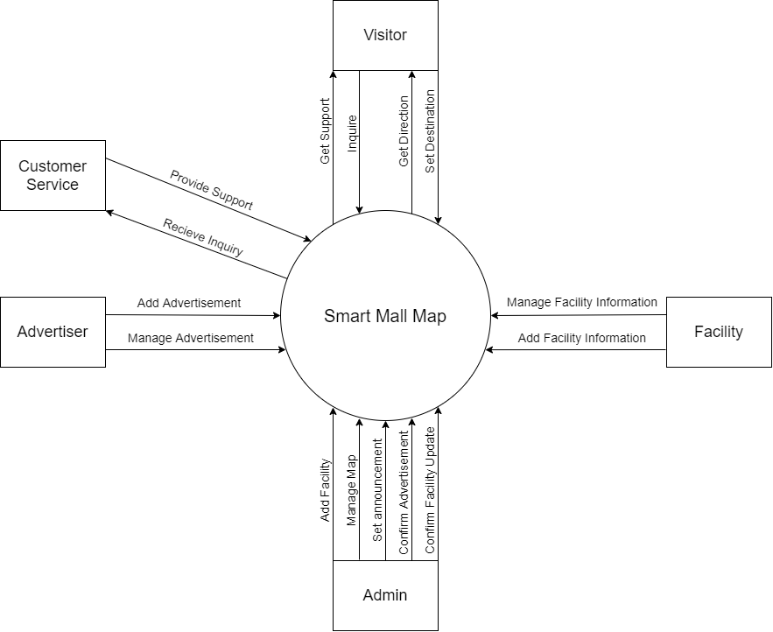

* **Use Case Diagram:**

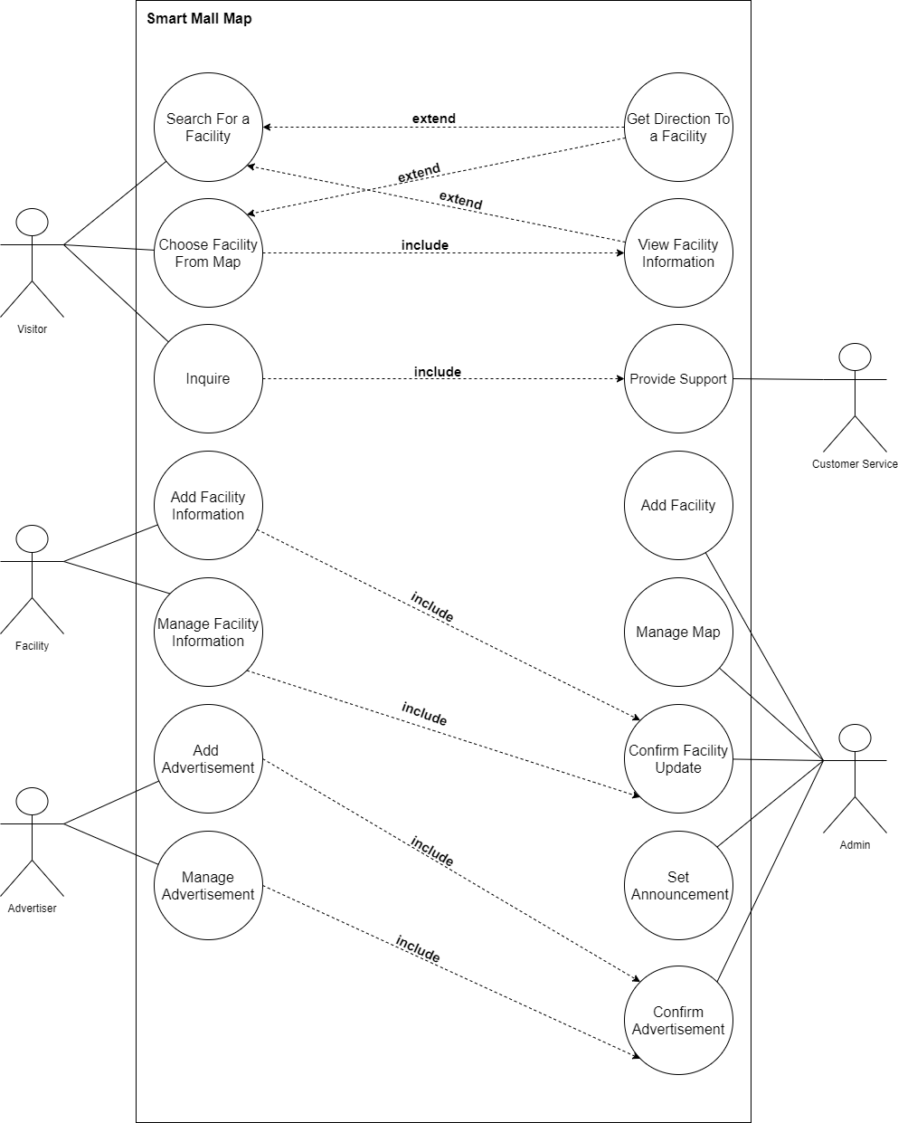

* **Use Case Scenarios:**

|  |  |
| --- | --- |
| ID | UC_01 |
| Title | Get direction to a facility. |
| Description | Visitor wants the directions to a facility in the mall and decided to use smart mall map. |
| Priority | High |
| Primary Actor | Visitor |
| Secondary Actor | N/A |
| Preconditions | * Screen is a wake * Visitor has chosen the level in the mall map. |
| Post-conditions | * Display the name of the facility visitor chose. * Display the direction form the current location to the chosen facility on the mall map to the visitor. |
| Main Success Scenario | 1-Visitor clicks on the facility he wants to get directions to it from the map.  2-Visitor click “Get direction” button. |
| Extensions | 1a-Visitor did not choose any facility from the map; system will alert the visitor to choose a facility first. |

|  |  |
| --- | --- |
| ID | UC_02 |
| Title | Inquire |
| Description | Visitor wants to reach customer service to describe his/her inquiry. |
| Priority | High |
| Primary Actor | Visitor |
| Secondary Actor | Customer Service |
| Preconditions | Map is open |
| Post-conditions | * System Display support for the visitor if any of the customer service did it for the visitor. * System Display “Thank you for reaching us”. * System record the Inquiry details. |
| Main Success Scenario | 1-Visitor click “Call Support” button from the map.  2-Visitor choose the type of his/her inquiry.  3-Visitor enter the inquiry message.  4- Visitor click “Send”.  5- System display "Please wait until the customer service respond". |
| Extensions | 4a- Visitor did not enter the message of the inquiry, system alert visitor to enter the message.  5a- Customer service is unavailable, System display alertion message "Sorry! Customer Service is unavailable right now". |

|  |  |
| --- | --- |
| ID | UC_03 |
| Title | Manage facility information. |
| Description | Facility want to update a facility information in the mall map and admin should confirm it. |
| Priority | High |
| Primary Actor | Facility |
| Secondary Actor | Admin |
| Preconditions | * Facility owns/rents a place in the mall. * Facility is logged in the system. * Admin is logged in the system. * There is already information about the facility in the system. |
| Post-conditions | * New information is updated on the Database system. * System display to facility “Your Information is successfully updated”. |
| Main Success Scenario | 1. Facility open their facility’s page. 2. Facility click “edit” in the page. 3. Facility edit information in the system. 4. Facility click “Save”. 5. System display “Waiting for admin’s confirmation”. 6. Admin confirms alteration on the facility’s information. |
| Extensions | 3a- Facility exist without saving, system alert “Are you sure you want to exist without saving”.  6a- Admin did not approve the confirmation of the facility’s alteration, the system should display to the Facility that admin did not approve on the alteration. |

* **Activity Diagrams:**

1. **Get Direction to a Facility Activity Diagram**

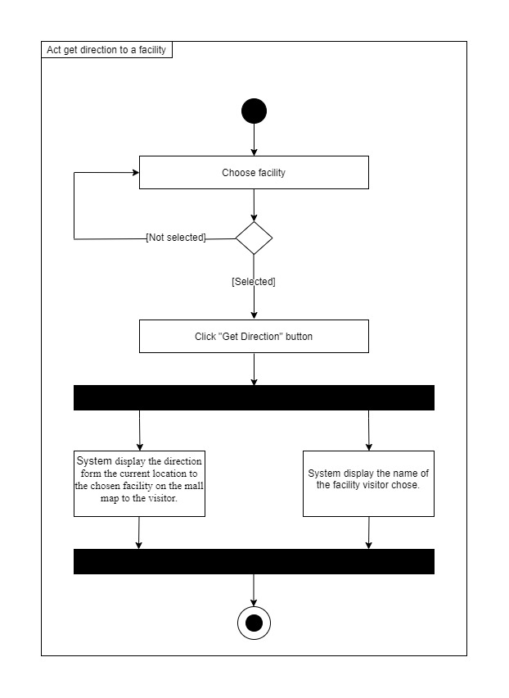

1. 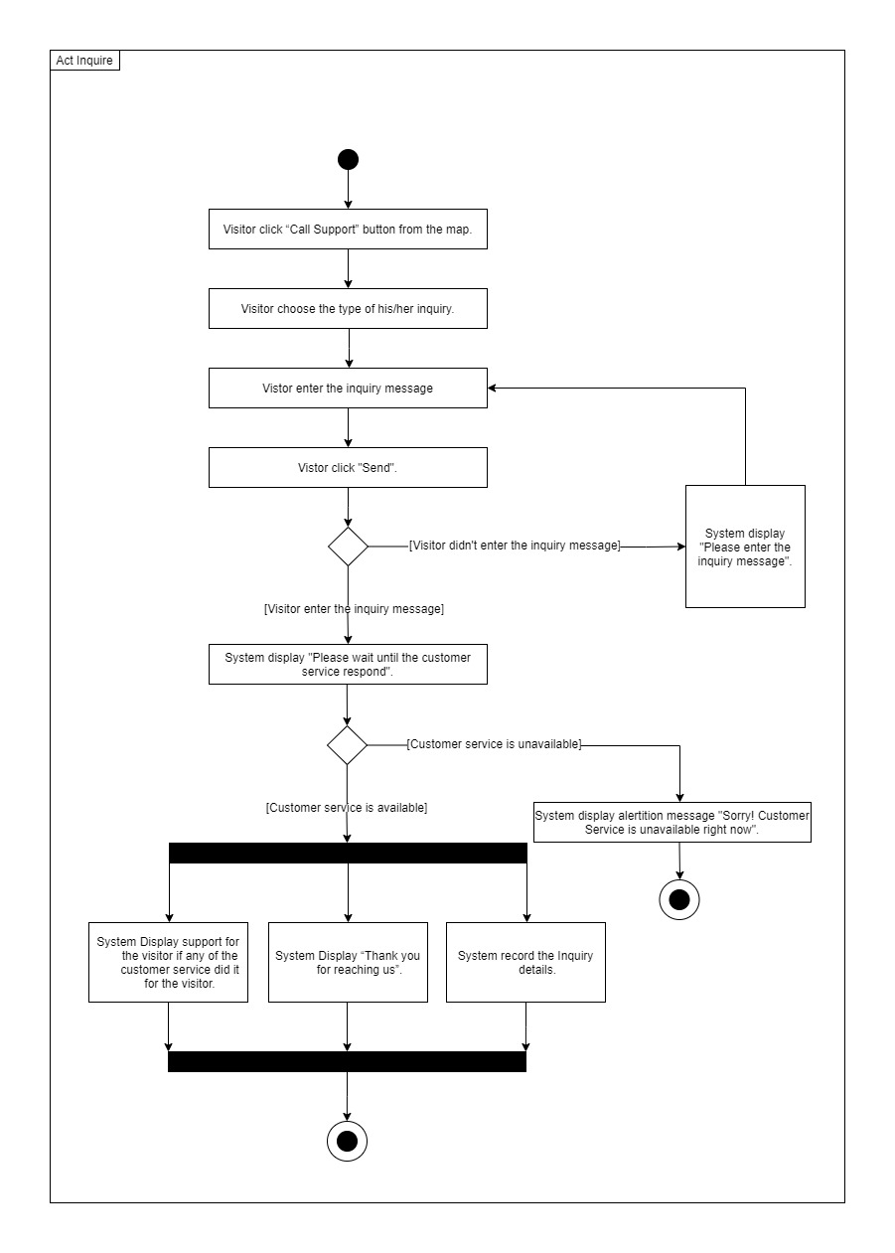**Visitor Inquiry**
2. **Manage Facility Information**

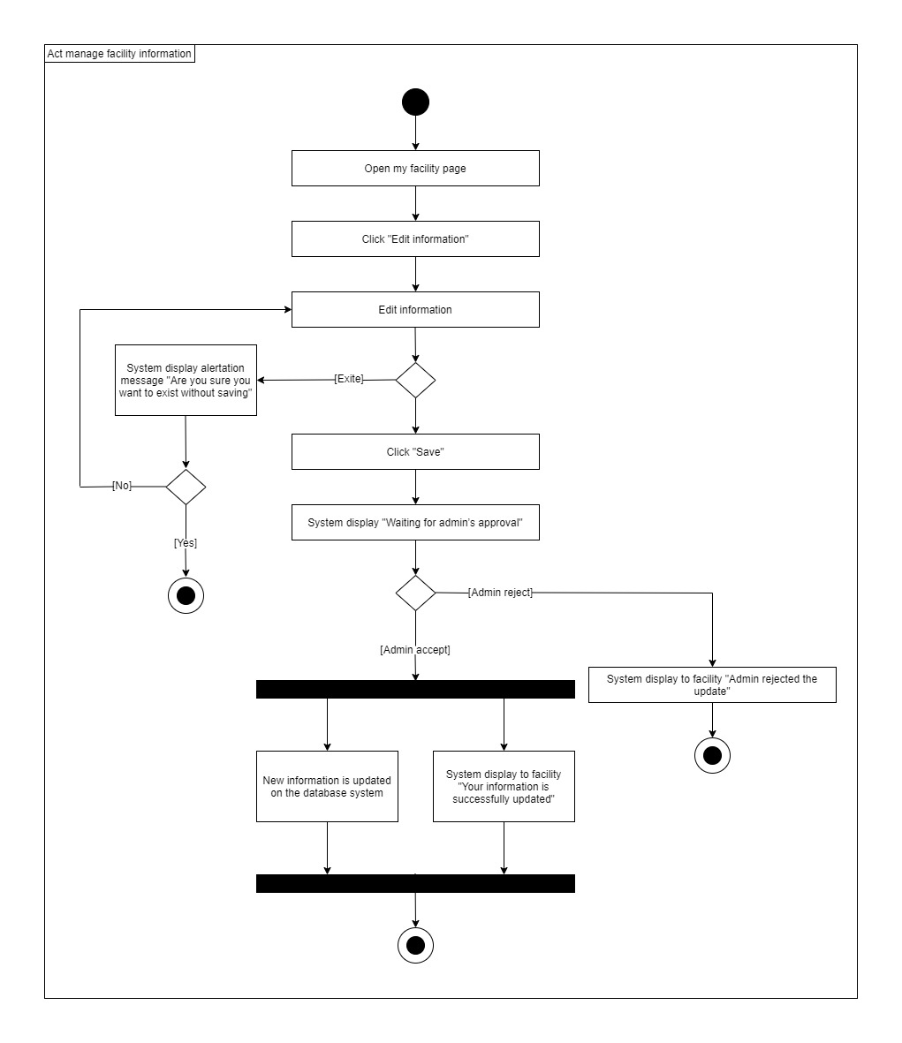

* **Sequence Diagrams:**

1. **Get Direction to Facility**

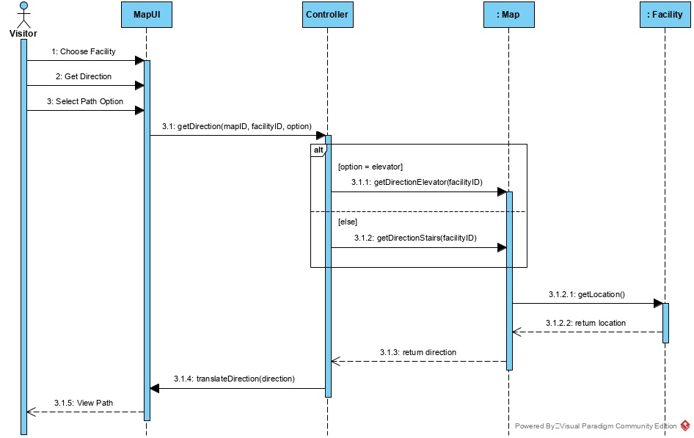

1. **Manage Facility Information**

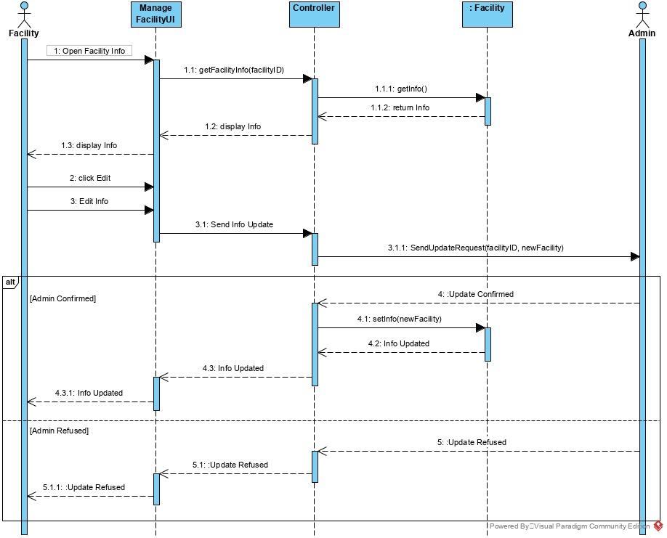

* **Class Diagram:**

* **Database Schema**

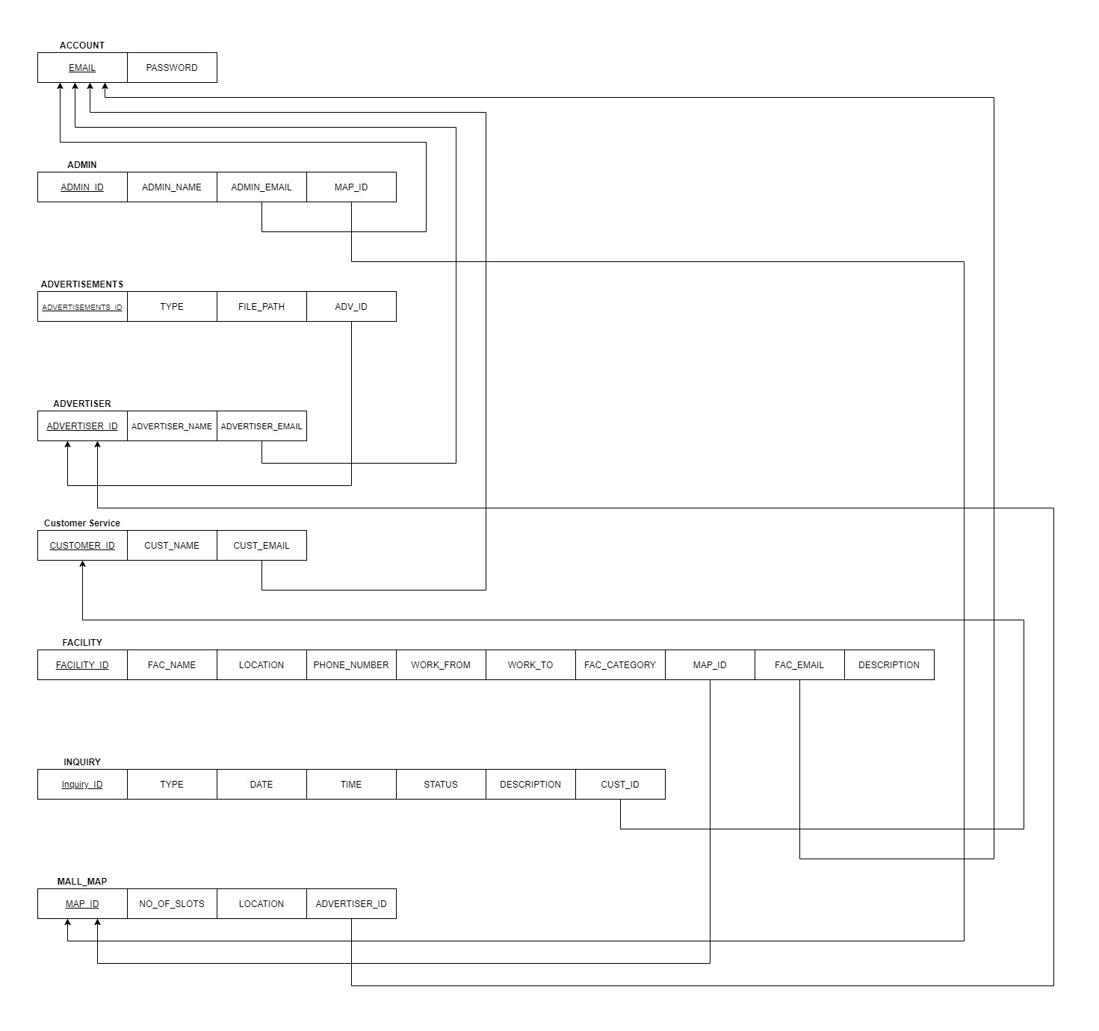

* **Implementation**
* 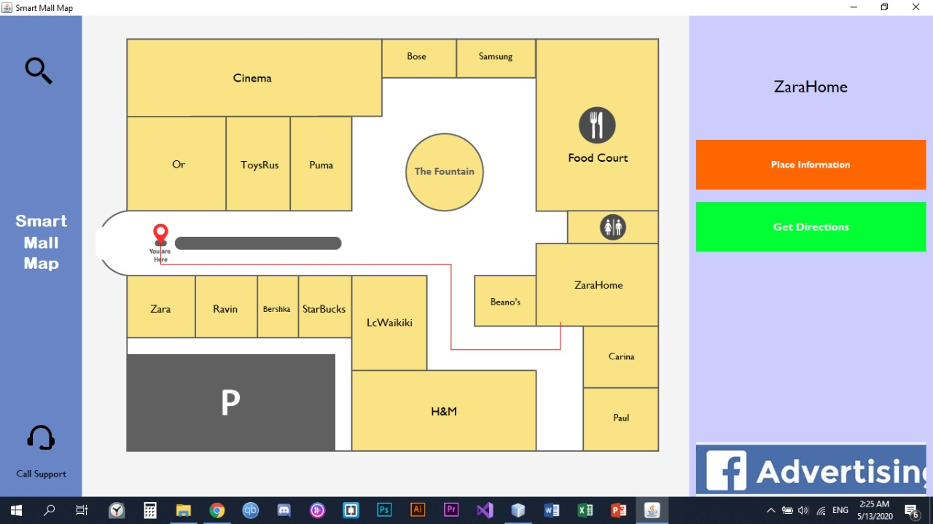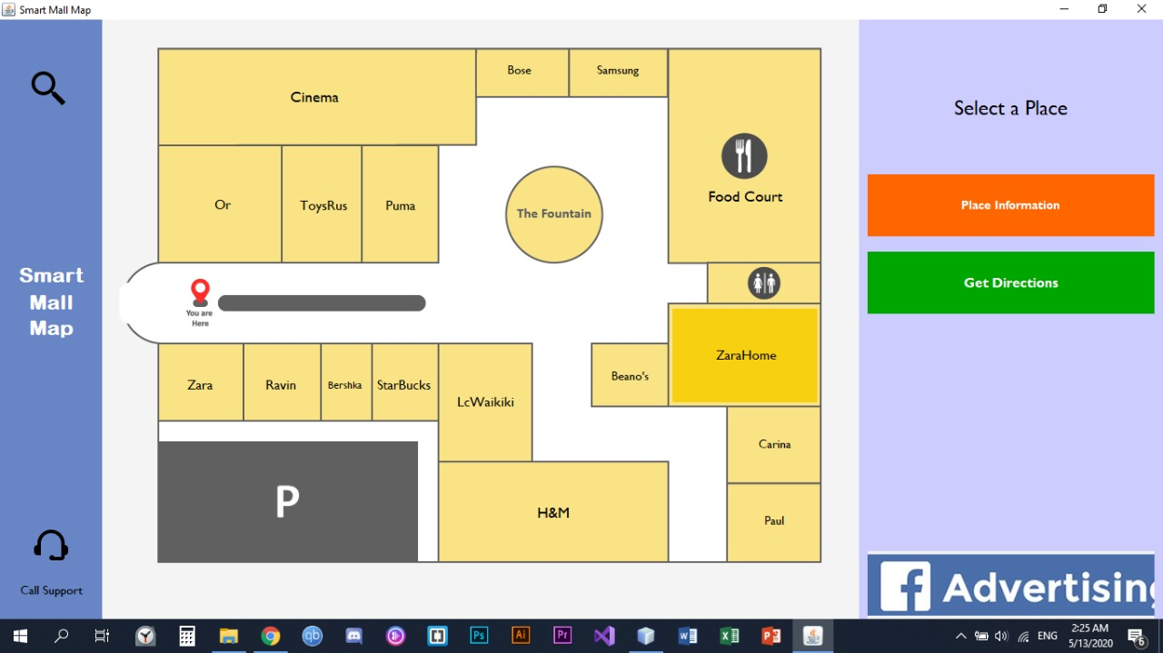**Some User Application Screenshots:**

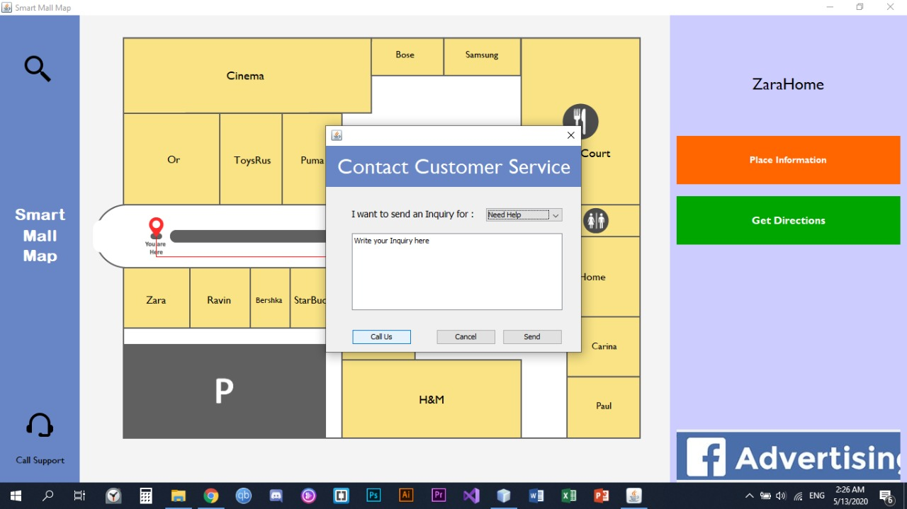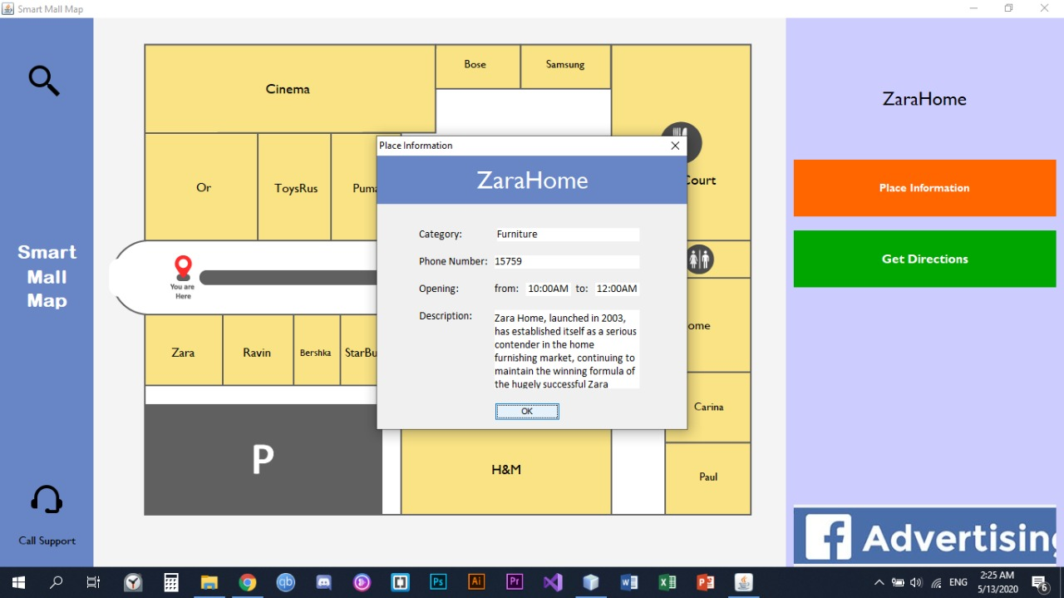

* **Some Facility Application Screenshots:**

